Learning Project WEEK 1- My Family
Age Range: ​EYFS
Weekly Maths Tasks (Aim to do 1 per day) | Weekly Reading Tasks (Aim to do 1 per day)
- Watch a Numberblocks clip each day at: BBC or ​ CBeebie​ s. Use this guide ​ her​ e​ to give you ideas on what to do with your children whilst watching an episode.  - Practise counting up to 20. This can be done through playing hide and seek, singing number songs, chanting, board games etc.  - Write out the digits 0 - 9.  - Practise recognising amounts up to fiv​ e ​ or up to te​ n ​ by playing these games. This can be done by reading a dice when playing board games, playing with cards, identifying how many food items on the plate etc.  - Sing Number songs to practice counting, reciting numbers in order, one more, one less using number songs: Five Little Ducks, Five Little Men, Ten Green Bottles | - Read a variety of books at home. Favourites can be repeated. Hearing the patterns of language in a story will support your child’s language development.  - Reception age children: Children to read to parents daily. Visit Oxford Owl for free eBooks that link to your child’s book band. You can create a free accoun​ t.​ Complete the linked Play activities for each book.  - With your child, look in magazines, newspapers and books for the tricky words they are currently learning. They could use a highlighter to highlight in magazines and newspapers.
Weekly Phonics Tasks (Aim to do 1 per day) | Weekly Writing Tasks (Aim to do 1 per day)

- Sing Nursery Rhymes and songs together. Add in actions and change the words. Can children think of different rhyming words to add in? Repeat old favourites and learn new rhymes. You can find an A-Z of Nursery Rhymes her​ e.​  - Daily phonics - Practice the sounds your child is working on and blend words. This can be oral blending (e.g. spoken out loud c-a-t) or written if appropriate. Interactive games.​  - Sing the song ‘Daddy Finger’​ - ​ Can your child change their voice for each person e.g. a deep voice for Daddy finger, a squeaky voice for Baby finger.  - Play phonics noughts and crosses. Draw  out a grid and write a letter, digraph, trigraph or tricky word in each part of the grid. Take it in turns to name what is written in the grid. If you say it correctly you can add your nought or cross in that square.  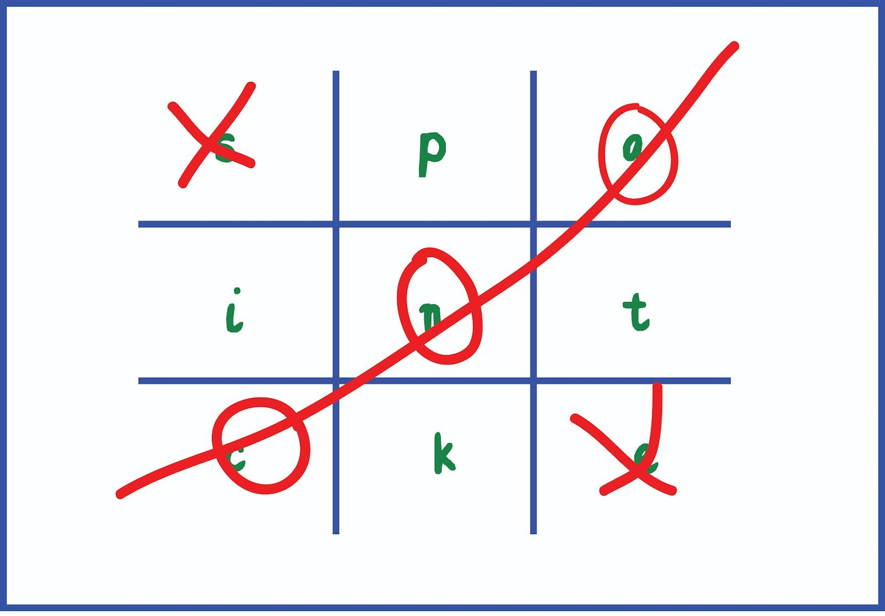 | - Ask your child to draw a picture of the people who live in their house. If they share time across two houses, draw who lives in each house. Can they label their family members using their phonics knowledge?  - Practice name writing. Can they write their first name? Middle name?  Surname?  - Can they write the names of their family members? Do they know Mummy and  Daddy’s real name? They could copy this or use their phonics knowledge. Can they write this? Using chalks, crayons, paint, felt tips.  - Practice forming the letters of the alphabet. Follow your school’s script.  - Ask your child to write out the tricky words they are working on at the moment on pieces of paper and turn them into a pairs game.
Learning Project - to be done throughout the week
The project this week aims to provide opportunities for your child to gain a better
understanding of their own family. Learning may focus on what different makeup of families, what traditions your family has, stories linked to your family etc.
- Look at a selection of family photographs and discuss the changes over time.​
○ Show your child a photograph of them as a baby, a 1 year old, a 2 year old. What could they do at that age? What can they do now that they couldn’t do then?
○ Look at a picture of a family member as a baby (this could be parents, siblings). Discuss how everyone was a baby once.
○ Are there any black and white photographs? Why are these photographs black and white? Do they show older family members when they were younger? Talk about how life was different then.
- Draw a family tree-​ How does your family link together? Can your child draw out their family members and link them together using lines?
- Do a picture survey of the people in your house. How many family members have blonde/​brown/ black/ red hair? Can you record this with pictures? How many people have blue/ brown/ green eyes?
- Have a family picnic. Lay out a blanket in the living room or garden. Can children make sure​ everyone has a plate, fork, spoon, cup? How many do we need all together? Give your child a selection of food and ask them to share it fairly between everyone? If there is one left over what could we do?
- Sort out the clean clothes. Who do they belong to? Can they deliver them to the right place​ in the house? Pair up socks. Can they match the patterns/ colours? Can they count in twos to work out how many there are all together? Peg clothes on the airer (this will support children to develop hand strength which will impact on their writing).
- Put on a show or performance-​ Perform a story or song to your family. Plan out costumes,
props. Children could make a show program.
- Lay the table for your family for dinner- How many people are there? How many knives,​ forks, cups do you need? Write out name cards for everyone in your family to show them where to sit. Write a menu to let them know what is for dinner that night. Roleplay as a waiter/ waitress. What would everyone like in their sandwiches for lunch? What drinks would everyone like to have with their dinner?
- Make a birthday card for the next family birthday- How old are they going to be? Can​ they write the numerals to show the correct age? Write a message inside for your family member and sign it with your name.
- What jobs do the people in your family do? Talk to your child about your job and what you​ do. What would they like to be when they grow up? Can they draw a picture of themselves in the job they would like to do?
Use play dough to make your family members- Use ready made play dough or make your​own using this recipe:
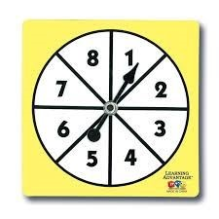
○ 2 cups of plain flour, one cup of salt, a tablespoon of oil, a cup of water (add gradually), a couple of drops of food colouring (optional), a teaspoon of cream of tartar (optional, but will make it last longer)
- Play a family board game- ​ Play a game together. Talk about taking it in turns​ and playing fairly. Dice games will support your child’s number recognition. You could use a spinner with numerals on to help develop numeral recognition. If you don’t have a spinner you could make one using an old cereal box and a split pin.
- Find out everyone’s favourite song in your family- Listen to each person’s favourite song and make up a dance to match. Do you like the same music? What is your favourite song?
Additional learning resources parents may wish to engage with
Classroom Secrets Learning Packs -​ These packs are split into different year groups and​ include activities linked to reading, writing, maths and practical ideas you can do around the home.
Twinkl ​ - to access these resources click on the link and sign up using your own email​ address and creating your own password. Use the offer code UKTWINKLHELPS.
Headteacherchat - This is a blog that has links to various learning platforms. Lots of these​ are free to access.
#TheLearningProjects

